**A Typical Day at LLPS**

**Arrival/Centers** – Upon arrival, children choose from a wide variety of centers to play in. Choices include, but are not limited to: riding bikes, puzzles, computers, painting, play-doh, books, building with blocks or Legos, dress-up, and imaginative play.

**Jesus Time** –A different Bible story is taught weekly, along with prayer and songs. Once a week, the lesson is taught by Pastor Meyer or Pastor Mike!

**Class Time** -Children separate into their respective classrooms.Both classes begin with opening activities including calendar and weather, time for sharing, and stories, songs, and finger plays. Both classes study 1 letter per week and work on important skills such as writing, number recognition, counting, sorting, and patterns.

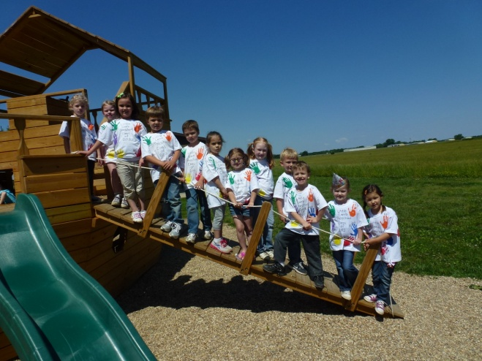**Play Time** - (gross motor skills) Weather permitting, children play outside on the playground. Otherwise, playtime takes place in the gym, with both free play and organized games.

**Themed Units** – Through the use of exciting themes, children will have a chance to explore and discover their world with books, songs, food, art projects and hands-on discovery activities.

**LITTLE LAMB PRESCHOOL STAFF**

**Doug Meyer, Pastor**

**Michael Feldmann, Associate Pastor**

**Ann Wilzbach, Director & Teacher**

**Taylor Jones, Teacher**

**Jessica Feldmann, Teachers' Aide**

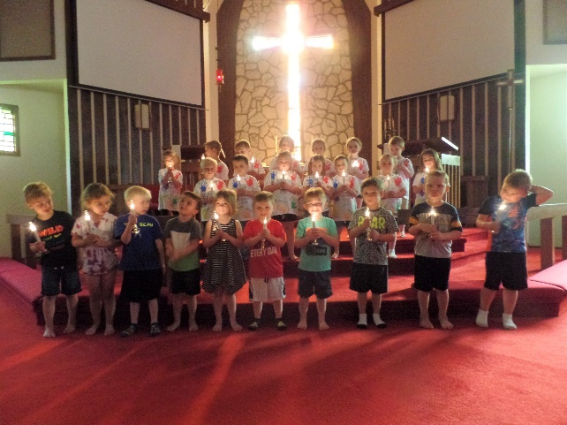

**Visit us online at:**

**salemlc.org**

**or on Facebook at:**

**littlelambpreschoolslc**

**Salem Lutheran Church invites you to Worship each Sunday morning at 8:00 and 10:15 a.m. Sunday School is at 9:10 a.m.**

**LITTLE LAMB PRESCHOOL**

**C:\Users\annie\AppData\Local\Microsoft\Windows\Temporary Internet Files\Content.IE5\0KP2HWW4\MC900021593[1].wmf**

**Salem Lutheran Church**

**1401 Hawthorn Rd.**

**Salem, IL 62881**

**(618) 548-3190**

**General Information**

Little Lamb Preschool is a non-profit preschool sponsored by Salem Lutheran Church serving children ages 3 through 5 years old.

**PHILOSOPHY**

"Feed My Lambs" John 21:15

At Little Lamb Preschool, we believe that Christian education is an important aspect of God's mission as commanded by Him to the Church. We offer opportunities for physical, spiritual, social, emotional, creative, and intellectual growth by providing children a positive, creative, stimulating, and orderly Christian environment. It is our hope, that by providing a well-rounded program and by developing the whole child, your children will go on to enjoy continued success in school.

**NON-DISCRIMINATORY POLICY**

Little Lamb Preschool serves the whole community and admits students of any race, color, religion, national, or ethnic origin to all the rights, privileges, programs, and activities generally accorded or made available to our students.

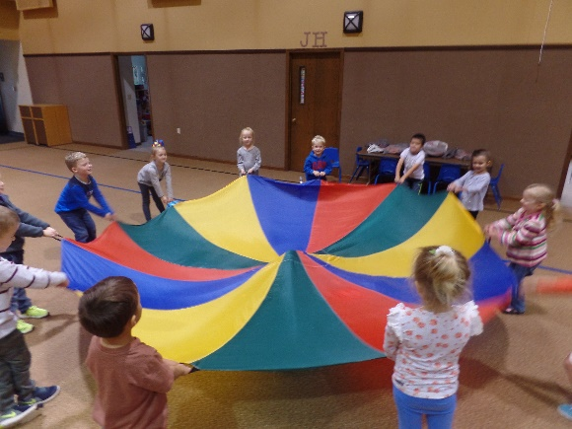

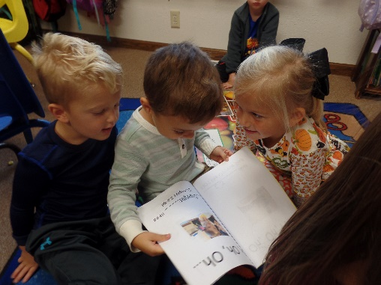

**PURPOSE AND VALUES**

The value of early childhood training is indicated in the Bible: "Train up a child in the way he should go, and when he is old, he will not depart from it." Proverbs 22:6. A Christian home gives a child his/her first Christian training and instruction. At Little Lamb Preschool, we share in the responsibility with you by providing a

loving, warm, secure environment where children receive Christian training and

instruction. Little Lamb Preschool accomplishes this by:

* Providing early Christian training and instruction;
* Assisting in the gradual adjustment from home to school life;
* Developing creative and academic abilities by providing experiences and materials that give many opportunities for exploring, thinking, and reasoning;
* Developing skills necessary for each child to find success and happiness in our ever-changing world;
* Promoting learning through work and play;
* Preparing each child with skills for future school success.

**PRESCHOOL PROGRAM**

We accept children who are at least 3 to 5 years of age by September 1, 2019. Children will be placed in one of two classrooms within each session, according to their age.

3-Day session: M,W,F 9:00–11:30 a.m.

2-Day session: T,Th 8:30 a.m-12:00 p.m. (when enrollment permits)

Both sessions are designed foster all aspects of each child's development. Our curriculum includes:

* Religion * Art

* Language Arts * Music

* Mathematics * Science

* Social Studies *Physical Education

**FEES AND TUITION SCHEDULE**

**2019-2020 SCHOOL YEAR**

*Yearly tuition - $810/yr. ($90/mo.)*

An annual registration fee of $35 per child, *plus* the first month's tuition is due at the time of application. A discount is offered to members of Salem Lutheran Church and families with 2 or more children enrolled at the same time.

Classes are filled in the order that applications are received. Church member registration begins February 17. Open registration for the entire community begins Monday, March 4.

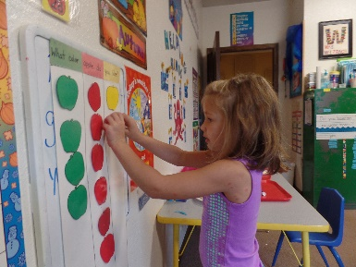Please contact the church office for an application or more information.